Teddy Bears’ Picnic Ideas and Activities.
Snack ideas for the picnic:
Pom Bears
Gummy Bears
Barney Bears
‘Decorate your own bear face’ pancakes.
Teddy Bear cupcakes/biscuits
Rice krispie buns
Make a teddy bear face using fruit, bananas, apples, oranges, grapes, melon, strawberries etc.
Rice cakes and crackers.
Jelly and Ice-cream
Teddy Bears buttons – Chocolate buttons
Etc.

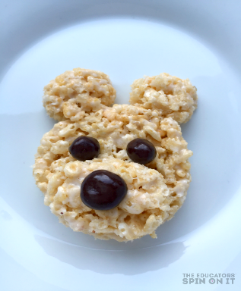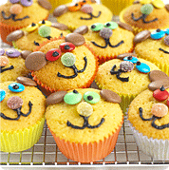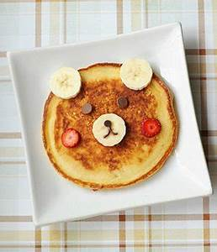

All of the above are just suggestions. Please do not feel under any pressure to get or make any of them. Keep it as simple and as a fun as possible.
Week: 22/06/20 – 26/06/20 | MONDAY | TUESDAY | WEDNESDAY | THURSDAY | FRIDAY
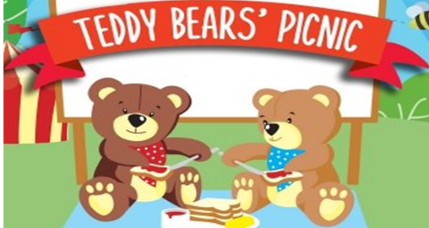

HAVE A TEDDY BEAR’S PICNIC ON THE DAY OF YOUR CHOICE
See list of suggestions above

Gaeilge | - Abair Liom Lesson 30- Súil Siar 6 is available to do throughout the week, if you wish: (Online) – Follow the activities as before. |  |  |  | HAPPY HOLIDAYS  EVERYONE
English | - Listen to and discuss the story ‘We’re going on a bear hunt’ https://www.youtube.com/watch?v=Waoa3iG3bZ4  - Complete the letter v handwriting page from the handwriting activity sheets. | - Listen to Teddy Bears Picnic Story https://www.youtube.com/watch?v=wwM3oN6B3co  - Complete the letter w handwriting page from the handwriting activity sheets. | - Learn the Rhyme Teddy Bear, Teddy Bear Turn around: https://www.youtube.com/watch?v=Tu_n94Wp3rg  - Complete the letter x handwriting page from the activity sheets. | - Listen to My Teddy Bear https://www.youtube.com/watch?v=666UZRBO5q8  - Complete the letter z handwriting page from the activity sheets.
Maths | Complete the Teddy counting Power Point. | Do the Colour by numbers page below. | Complete the Teddy Bear Exploration page below. | Pick from one of the extra activities/Teddy Bear Olympics below.
SESE | - Bear hunt map Complete the bear hunt map below. Cut out the pictures and sequence them in order of how they appear in the story.
PE |  | - Do an activity of your choice.  Some suggestions for this week would be to do :  - ‘We’re going on a bear hunt’ Cosmic Yoga: https://www.youtube.com/watch?v=KAT5NiWHFIU  - Teddy Bears Picnic dance  https://www.youtube.com/watch?v=1_jNgirWeQY  - Gummy Bear Dance https://www.youtube.com/watch?v=6Q7-tzCCh3w (Warning: this song may get stuck in your head!)  - Teddy Bear Olympics
Music |  |  | - Song singing  Listen to the Teddy Bears Picnic Song: https://www.youtube.com/watch?v=YDndFOtBy-E  Song with words: https://www.youtube.com/watch?v=1_jNgirWeQY
Art |  |  |  | How to draw a Teddy Bear https://www.youtube.com/watch?v=U8F4au3VAh8
Extra Activities | - Make a shopping list for the picnic.  - Make your own decorations- Paper Chains, bunting etc.  - Guess how many gummy bears are in the jar.  - Teddy Bear Face Painting or make a teddy mask or crown with teddy bear ears.  - Relaxation: Belly breathing with your teddy on your belly rising up and down.
Teddy Bear Olympics
Teddy Bear Relay- Basket of teddies at the start line and an empty basket at the finish line. The children must take a teddy and put it in the empty basket and keep going until the basket at the starting line is empty. Race against someone or try and beat your time.
Balance your bear- Walk around with your teddy balanced on your head/shoulder etc. Trying hard not to let it fall.
Teddy Throwing Contest- Who can throw their teddy up the highest/the furthest away? Can you throw your teddy up and clap before you catch it?
Obstacle Course- Make an obstacle course for you and your teddy.
Teddy Bear Hide and Seek.
Teddy Bear Dance Off
Teddy Bear Aerobics- Jumping jacks, planks, burpees etc. with your teddy.
Target throw- Throw your teddy into a hula hoop/basket.
Teddy Races/Relay Races

